Appendix C: IEEE 830 Template
Software Requirements Specification for
«Lost and Found Portal»

Version «1.5»

Prepared by «Alua Arinova» & Amira Amrenova

«04.03.2026»

Table of Contents

«Table of Contents»

Revision History
Name | Date | Reason for Changes | Version
Arinova Alua | 04.03.2026 | Initial version | Version 1.0
Amrenova Amira | 10.03.2026 | Add diagram | Version 1.1
Amrenova Amira | 18.03.2026 | Class diagram | Version 1.2
Amrenova Amira | 25.03.2026 | Diagram | Version 1.3
Amrenova Amira | 04.04.2026 | 3 diagram | Version 1.4
Arinova Alua  Amrenova Amira | 17.04.2026 | add more info and fix document | Version 1.5

Introduction

  - Purpose

This document describes the requirements for the software and architecture of the "Lost and Found Portal" system. The purpose of the document is to identify the functional and non-functional requirements of the system so that developers, testers, and stakeholders can understand how the system should work.

Document Conventions

The following designations are used in the document: REQ-x.x -functional requirements
NF-x.x - non-functional requirements

The word "shall" means a mandatory requirement of the system

The numbering of sections is organized hierarchically (1.0, 1.1, 2.0, etc.) Each requirement has a unique number for easy verification.

Intended Audience and Reading Suggestions

This document is intended for the following user groups:

Developers: Use the document to implement the system.

Project Managers: They use the requirements for development planning. Testers
Create test cases to test the functionality. System Administrators: They are responsible for system management and support.
Users: They can get acquainted with the system's capabilities.
Document structure
Section 1 — Introduction

Section 2 — general description of the system Section 3 — the main functions of the system Section 4 — Interface requirements
Section 5 — Detailed functional requirements Section 6 — Non-functional requirements

Product Scope

The Lost and Found Portal is a web—based system designed to search for lost and found items. The system allows users to post information about lost items, post found items, search for them in a database, and communicate with each other.

The main purpose of the system is to simplify the process of searching for lost items and make it faster. The system also helps to create a single place to store information and facilitates communication between users. The advantages include fast search, a convenient database, and access from any device with an Internet connection.

References

The following sources were used to create this document:

IEEE 830 — Software Requirements

Specification Standard Methodological guidelines on the subject of Software Engineering User Interface Design Guidelines
Web Development Documentation

Overall Description

  - Product Perspective

The Lost and Found portal is a new independent system. Nowadays, people often use social media or regular ads to report lost items, which is not always convenient. This system offers a more efficient solution - a centralized online platform. Integration with other systems, such as universities, transportation services, or mobile applications, is possible in the future.

Product Features
The system includes the following features:

    - registration and login
    - adding lost items
    - adding found items
    - searching for items
    - viewing item details
    - contacting other users
    - admin panel

User Classes and Characteristics

Regular users are people who want to find or report lost items. They usually have basic Internet skills and use the system infrequently. Registered users have an account and can add ads, edit them, and connect with other users. Administrators are responsible for managing the system. They can delete ads, manage users, and monitor the system.

Operating Environment

The system is a web application and runs on different operating systems such as Windows, Linux and macOS. It supports modern browsers such as Google Chrome, Mozilla Firefox, Microsoft Edge and Safari. The server part includes a web server (Apache or Nginx) and a database (MySQL or PostgreSQL).

Design and Implementation Constraints

The system should be implemented as a web application and run in modern browsers. It is necessary to ensure the security of user data and use the database to store information. Python, HTML, CSS, JavaScript, and server technologies such as Node can be used as technologies.js, Django, or PHP.

User Documentation

The system will provide a user's guide, online help, an FAQ section, and an administrator's guide. The documentation will be available in PDF format and as webpages.

Assumptions and Dependencies

It is assumed that users have access to the Internet and enter the correct information. The system's operation depends on an Internet connection, a web server, and a database management system.

System Features

3.1User Registration
This feature allows a new user to create an account in the system.

3.2 User Login
This feature allows a registered user to log into the system using their credentials.

3.3 Report Lost Item
The user can add information about a lost item, including description and optional image.

3.4Report Found Item
The user can post details about an item they have found.

3.5Search Items
The user can search for lost or found items using keywords or filters.

3.6Contact User
The system allows users to contact each other regarding items.

3.Admin Panel
Administrators can manage users and remove incorrect or inappropriate posts.

External Interface Requirements

  - User Interfaces Overview

The system will have a graphical user interface (GUI) accessible via a browser. The user will interact with the system using buttons, forms, and menus.

The main pages of the system:

main page, login and registration page, page for adding a lost item, page for adding a found item, search page item, information page

The admin panel.

The interface should be simple and clear.

The system should also show error messages and action confirmations.

Hardware Interfaces

The system works on common devices: computers, laptops, and smartphones. No additional equipment is required.

Software Interfaces

The system interacts with a web browser, a database server, a web server, and an email service. User data, information about items, and messages between users are transmitted.

System Features/Modules

This template illustrates organizing the functional requirements for the product by system features, the major services provided by the product.

User Registration

Description and Priority
This feature allows a user to create a new account in the system. Priority: High

Stimulus / Response Sequences

Stimulus: User fills in the registration form and submits it. Response: The system validates the data and creates a new account.

Stimulus: User enters invalid or incomplete data. Response: The system shows an error message and asks to correct the input.

Functional Requirements

FR-01: The system shall allow users to register using email/password.
FR-02: The system shall allow users to log into their accounts.
FR-03: The system shall allow users to report lost items with description and optional image. FR-04: The system shall allow users to report found items.
FR-05: The system shall allow users to search for items using keywords.
FR-06: The system shall allow users to contact other users through the platform.

Nonfunctional Requirements

NFR-01: The system shall respond to user actions within 2 seconds. NFR-02: The system shall ensure secure storage of user data.
NFR-03: The system shall be available 99% of the time.
NFR-04: The system shall be compatible with modern web browsers.

Class Diagram

Use-Case diagram

Sequence Diagram

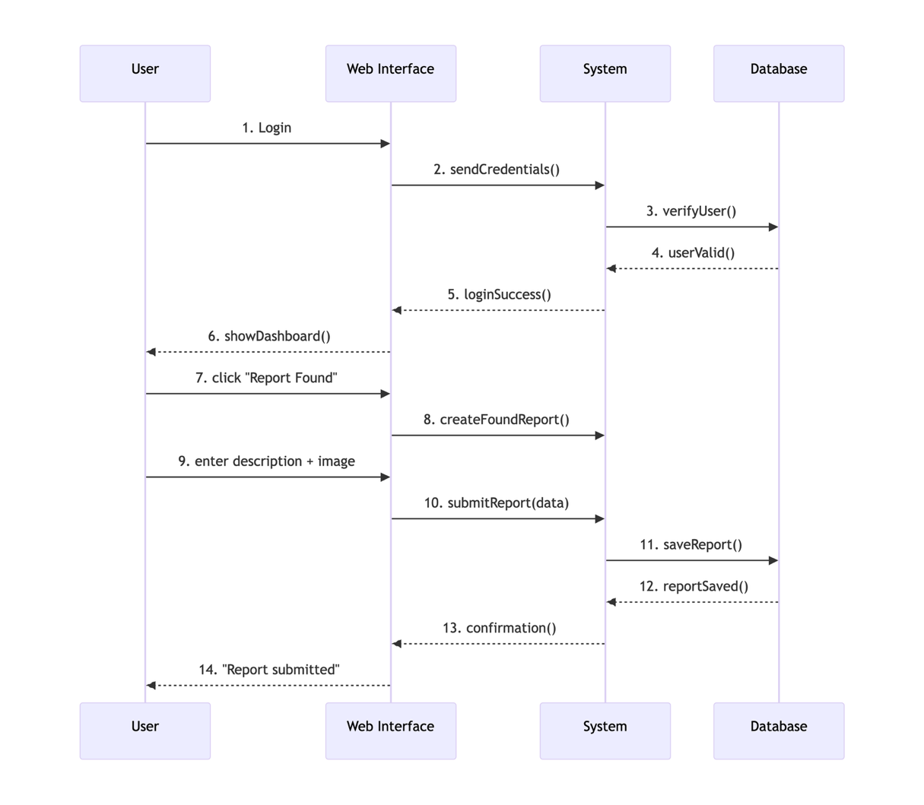

Activity Diagram
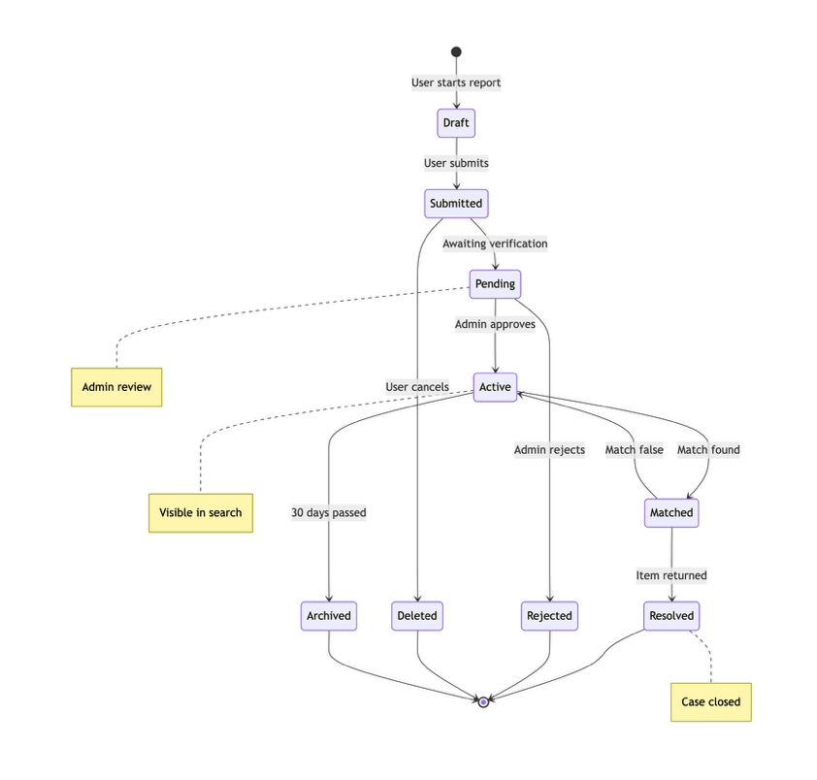

State Diagram
